CCT Color Temperature Mode
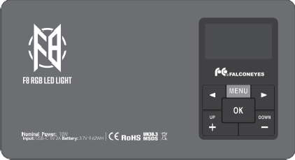
CCT Color Temperature: Adjustable range from 2500K to 9999K, adjustable in 50K increments.
16 mm
132 mm
Charging Port Power Switch Type-C
Brightness: Adjustable range from 0% to 100%, adjustable in 1% increments.
GM Tint: Red and green tint adjustment, adjustable from 1.00M (red) to 1.00G (green), in 0.01 increments.
70 mm

SCENE Special Effects Mode
Special Effects Mode: 20 scene options available.
Light Speed: Range from 0 to 10, where 0 is stopped, and 10 is the fastest. Effect Brightness: Range from 0% to 100%, adjustable in 1% increments.


1/4Thread
Lightning 1
Lightning 2 Screen Candle Flash Strobe Beam

Function Selection







Double flash Heart Police car Fire truck Ambulance HSI demo(slow) HSI demo（fast）

CCT color temperature, effect mode, HSI mode, RGB mode, and system language
— five function menu options. Press the button to cycle through the next function menu in order. Press the "OK" button to activate.

Function Confirmation
Press to activate the displayed menu function.

Red flash Green flash Blue flash PARTY 1 PARTY 2 RGB Strobe

HSI Hue Mode
Hue: Color range from 0° to 360°, adjustable in 1° increments. Saturation: Range from 0 to 100, adjustable in 1-unit increments.
Intensity (Brightness): Range from 0% to 100%, adjustable in 1% increments.

Parameter Selection
Select the parameter you want to adjust. The selected parameter will be highlighted.

Parameter Adjustment
Adjust the selected parameter. In the system language menu, select the system language.

RGB Color Mode
R (Red): Range from 0 to 255, adjustable in 1-unit increments.
G (Green): Range from 0 to 255, adjustable in 1-unit increments. B (Blue): Range from 0 to 255, adjustable in 1-unit increments.

LANGUAGE
Supports Chinese and English

RGBWW
Five-Color Mixing Light

2500K-9999K
Adjustable Wide Color Temperature

CRI 97+
High-Fidelity Color Rendering


Manual

20 FX
Scene Lighting Effects

